How to Use PVTP
Good day to my fellow young engineers.
I know the move from classroom to work desk is very hectic. It’s harder to understand things, and the skills you have always used to excel can seem somewhat subpar now.
Hang on. You are not alone, and you are doing fine.
This document is specifically for those in oil and gas. I created it to explain how to use the PVTP software for PVT analysis. I hope it makes someone’s journey easier.
Thanks.

HOW TO USE PVTP
BY ANNIE O.
DISCLAIMER
I am not a professional, I just like learning and sharing.
I used the WF OIL REC sample CL-70055, which I got from Whitson.com
https://manual.pvt.whitson.com/certificate/data_digitalization/pvt_experiment_data/
Software used is PVTP by PE(Petroleum Experts).
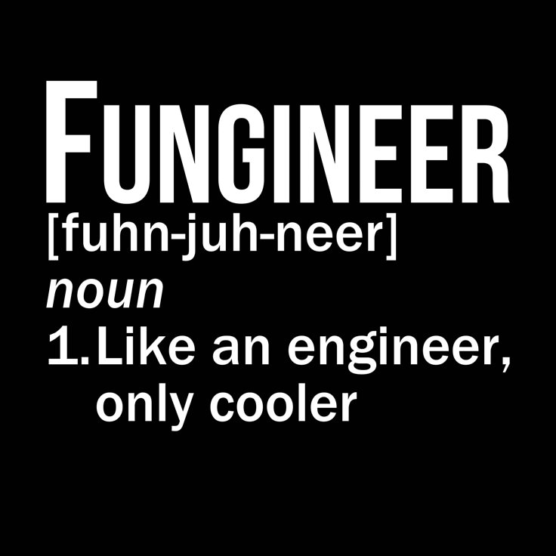

WHAT IS PVT?
PVT stands for Pressure, Volume and Temperature. It refers to the laboratory analysis and experiments used to characterize reservoir fluids and to understand how their properties and phase behaviour change with pressure and temperature. PVT analysis helps us understand how the fluid will behave under reservoir and surface conditions as it is produced from the reservoir to the surface.

WHY DO WE PERFORM PVT ANALYSIS?
- To understand how the reservoir fluid behaves and how its properties change under different pressure and temperature conditions.
- To characterize the fluid and develop a reliable PVT model that can be used for material-balance calculations, reservoir simulation and dynamic modelling.
- To provide the fluid-property and phase-behaviour information required for the design and operation of surface facilities, such as separators and other processing equipment.

DATA OBTAINED FROM PVT ANALYSIS

1. Compositional Analysis
Compositional analysis determines the chemical composition of the reservoir fluid by identifying the individual components and heavier hydrocarbon fractions present. It shows us how much of each pure hydrocarbon (C1, C2, C3), non-hydrocarbon (nitrogen, carbon dioxide) and pseudo-component is in the fluid. Pseudo-components are heavy fractions grouped together and written with a plus sign after them, e.g. C7+. The heavy fractions are characterized using properties such as molecular weight, density/specific gravity and other properties required for fluid modelling.

2. Constant Composition Expansion (CCE)
The Constant Composition Expansion experiment is used to study how fluid volume and phase behaviour change as pressure changes while the overall fluid composition stays constant.
No fluid is removed from the cell. For an oil system, as pressure is reduced below the bubble point, gas evolves from the oil, but the liberated gas stays inside the cell. Important information from this experiment includes the bubble-point pressure, relative volume and phase behaviour.

3. Differential Liberation Experiment (DLE)
The Differential Liberation Experiment is primarily used for reservoir oils. It is used to determine how the oil and the liberated gas behave as pressure is reduced below the bubble point.
At each pressure stage, the gas that evolves from the oil is removed from the cell, and the volume of the remaining oil is measured. Measurements from this experiment give us properties such as the oil formation volume factor (Bo), the solution gas-oil ratio (Rs), oil density and oil viscosity.

4. Constant Volume Depletion (CVD)
The Constant Volume Depletion experiment is primarily used for gas-condensate and other retrograde systems.
Pressure is reduced in stages while the cell volume is kept constant. Below the dew point, liquid condensate forms. At each stage, gas is withdrawn from the cell to bring the volume back to its original value. Measurements such as condensate dropout, produced-gas composition and the properties of the withdrawn gas can be obtained.

AIM OF PVTP
The main aim of PVTP is to develop and tune a fluid model that adequately reproduces the experimentally measured PVT data.
We provide the software with information from laboratory experiments, such as fluid composition, PVT measurements and viscosity data. The software uses an equation of state (EOS) and fluid-characterization methods to calculate the expected fluid properties.
The calculated results are then compared with the laboratory measurements. Where significant differences exist, the fluid model can be tuned by adjusting appropriate parameters. This process is repeated until the model gives an acceptable match to the experimental data.
Once the model reproduces the laboratory data, it can be used to predict fluid properties at other pressure and temperature conditions where laboratory measurements are not available. The fluid model can then be used in material-balance calculations, reservoir simulation, production forecasting and surface-facility design.
Okay, let’s get right into it.

STEP 1: EXTRACT YOUR DATA
The first thing to do when you get your lab report is to extract the necessary data into an Excel sheet. For this example, I am using the CL-70055 data (I will link it).
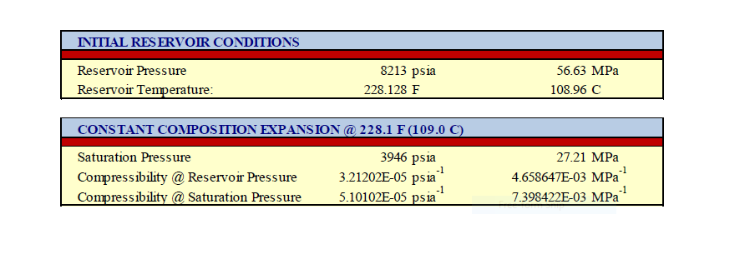

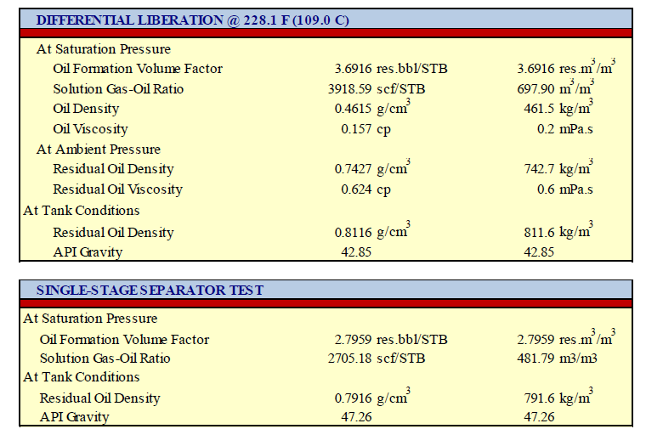
This is the basic data we need. It includes the reservoir pressure, temperature, bubble point and every other piece of data we may need for this field. For this example, use a depth of 7546 ft.
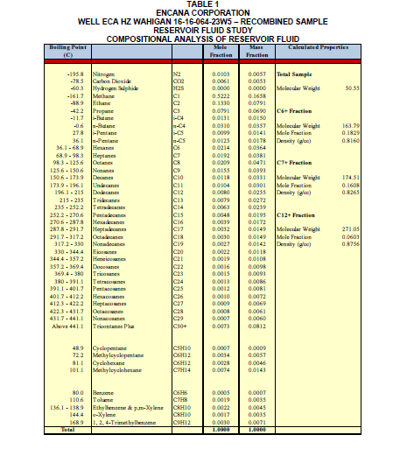
This is the compositional analysis for this field. It lists the hydrocarbon components and their corresponding molar percent (mol %), which is what will be input into PVTP. The properties of the pseudo-components are also listed.
The fluid composition comes in two forms, surface and downhole:
- Surface: the fluid is sampled at the separator (separator liquid and separator gas) and then recombined to represent the fluid downhole.
- Downhole: the fluid is taken using bottom-hole sampling. It represents the fluid at reservoir temperature and pressure.
All the molar percents must add up to 100.
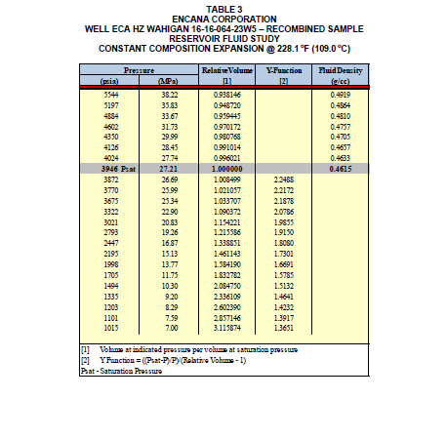
This is the CCE data. The two columns we use for this example are pressure (psia) and relative volume. The main property we get from this experiment is the bubble point.
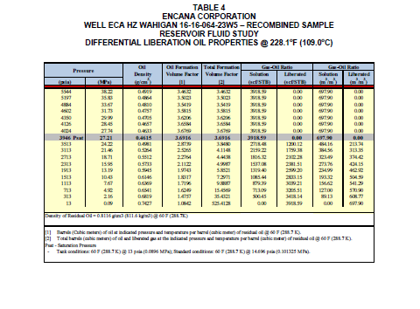
This is the differential liberation experiment. The columns we use are pressure (psia), oil density, oil formation volume factor (Bo) and solution gas-oil ratio (Rs, scf/stb).
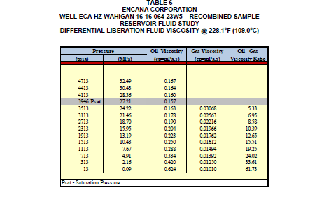
The last table is the oil viscosity table. Sometimes viscosity is included in the DL table. On occasions like this, where it has its own table, we must harmonize the pressures and interpolate or extrapolate the missing viscosity values. The column we use is oil viscosity. Viscosity is usually regressed and calculated separately in the PVT software.

STEP 2: QA/QC TEST
Next, we test the integrity of our data.
This data (CL-70055) does not need a QA/QC test because the composition came from a downhole sample.
If it were surface data, we would create two new columns, xi/zi and yi/zi, and plot yi/zi against xi/zi. Here x is the separator liquid composition, y is the separator gas composition and z is the recombined composition. Then we find the R² value. The closer it is to 1, the more consistent our data is.
Example (this is not CL-70055, it is just another example to explain the QA/QC test):
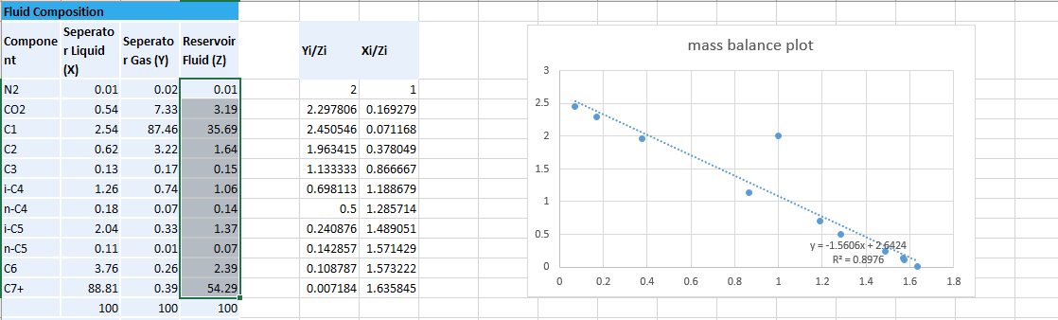

STEP 3: SET UP PVTP
- In the PVTP software, click File, then New.
- Click Options, then Units, and change the units you need: density from kg/m³ to g/cc, and pressure to psia.
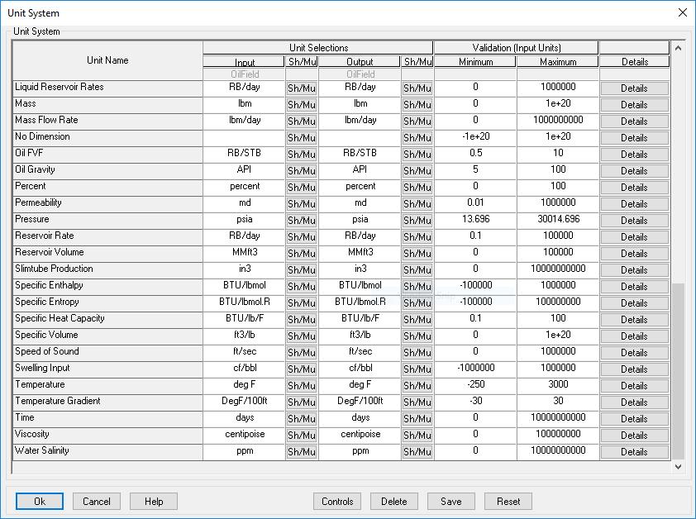
- Click Data. You can enter the data either as individual components or as a list.
Individual components: you will see the components PVTP accepts. Choose the ones that correspond to your data, click Enter Composition and input the values. A page then opens where you input the molecular weight of the pseudo-component, the reservoir temperature, the reservoir (initial) pressure and the reference temperature. Then click Pseudo Properties.
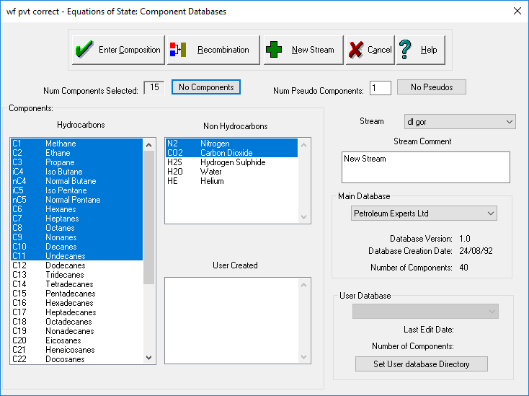
List: click Data, then Enter Components as List, and paste your components directly from your Excel sheet. Once pasted, click Verify. The software identifies the hydrocarbons, the non-hydrocarbons and the pseudo-component (the last component, with a plus sign after it, e.g. C7+, C12+). Then click Enter Composition. A page opens where you input the molecular weight of the pseudo-component, the reservoir temperature, the reservoir (initial) pressure and the reference temperature. Then click Pseudo Properties.
Once you click Pseudo Properties, a new screen appears. Input the specific gravity and boiling point (if you have them), click Calc Values, then Automatch. This calculates the properties of your pseudo-component. Then click Exit and save.
The last stage is to input your experiment data. Click the purple beaker icon and you will see the various experiments: Psat, CCE, DL, CVD, etc. Psat, CCE and DL are used for this example. Take the information from your extracted data and put it into the matching columns.
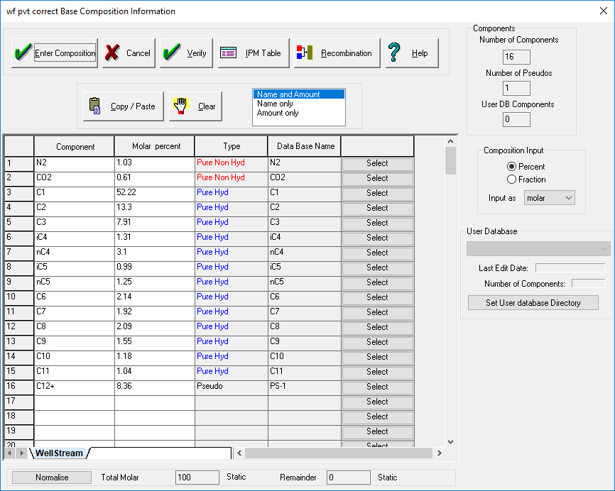
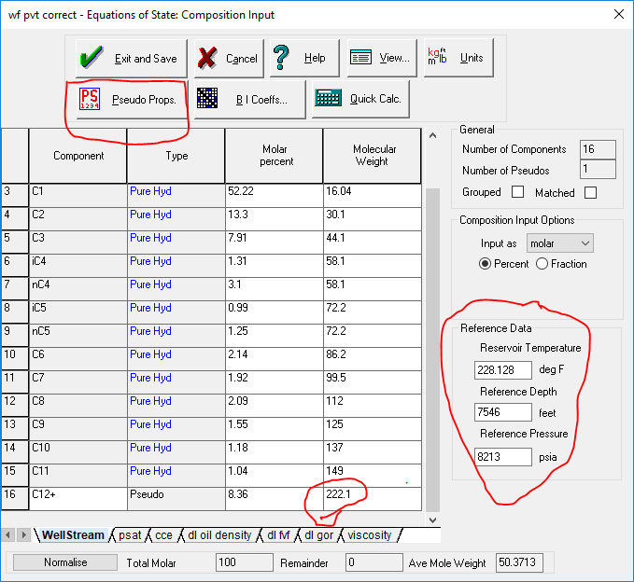
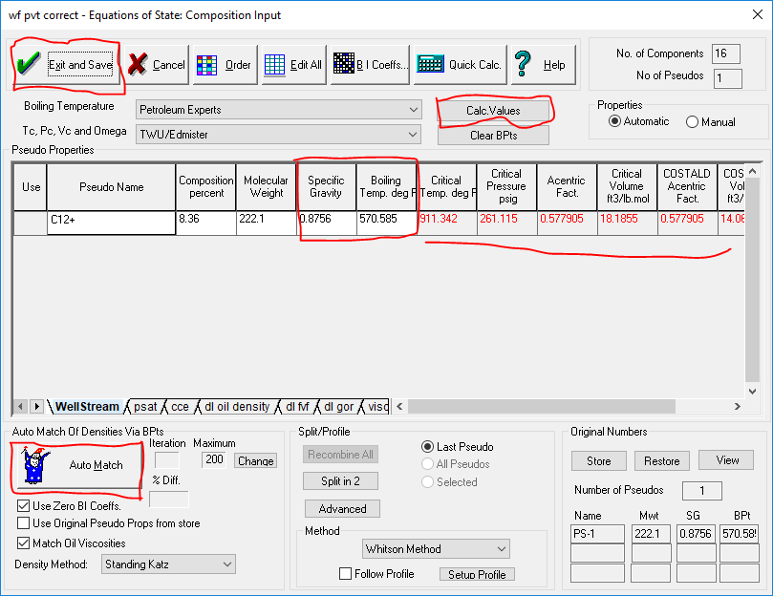
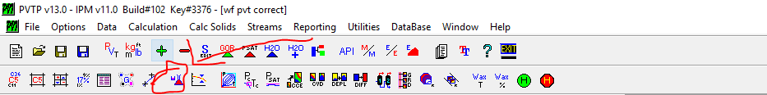

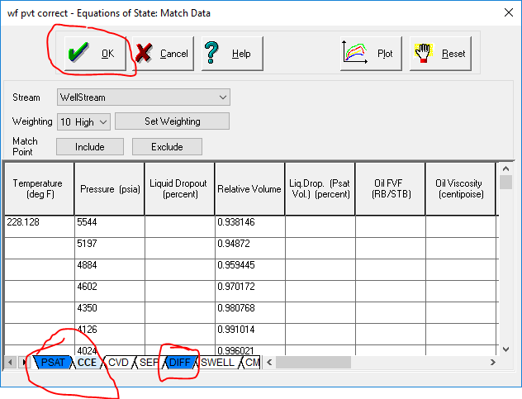

STEP 4: PSAT
The first thing we do is copy our existing stream. Creating a stream is like creating a particular fluid that you want the software to work with. When we start manipulating the stream, we are changing things about that fluid. To preserve our fluid, we copy the stream, so if anything goes wrong we still have a reference for a good fluid.
Click the + button above, then Copy Existing Stream, and name your new stream. We will name ours Psat.
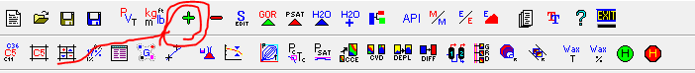
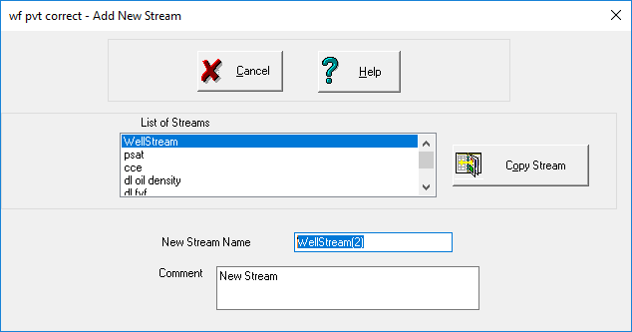
Next is regression. When we regress, we tell the EOS to tune the stream towards certain properties, in this case the saturation pressure. The lower the error, the better the regression.
- Click the icon that looks like a scatter graph, then toggle Saturation Pressure (Bubble Point) and Density at Saturation Pressure.
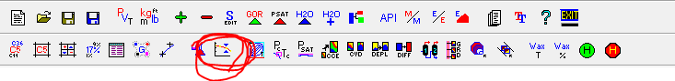
- Under the Lab Data column, click Ranged Psat. Set the formula for oil and gas viscosity to any one you like and click Regress.
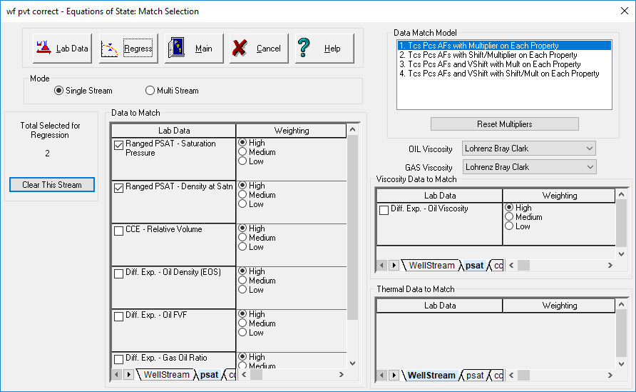
- Another screen pops up showing the parameters you can adjust to tune the regression. Click All On, then Clear Pure, then Regress.
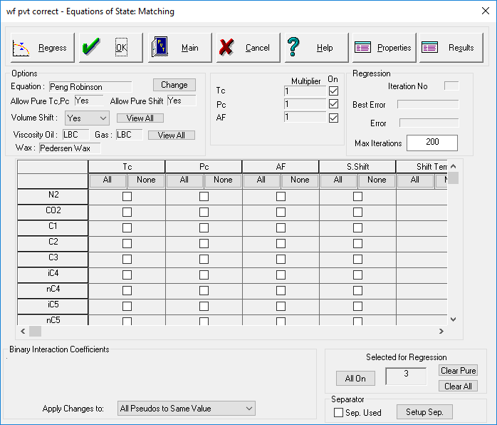
- Go to the ribbon and click the Psat icon. Insert the temperature (make sure it is on Automatic first), set the number of values to one, and click Calculate. A new screen appears; click Calculate again.
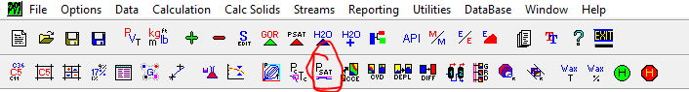
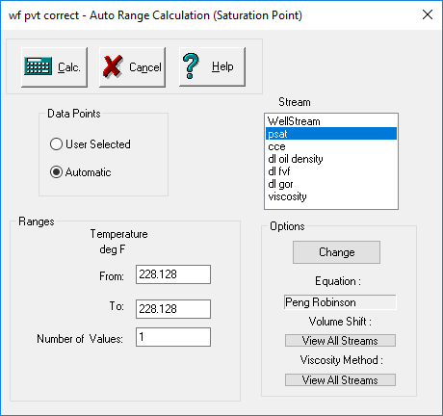
Compare the calculated Psat with the lab value. A common rule of thumb I use is that a result within 3% of the lab value is a good match. If it is not, you still have some regression to do, or you need to change one or two parameters to get a better match. Once the match is good, click Main to save your work.
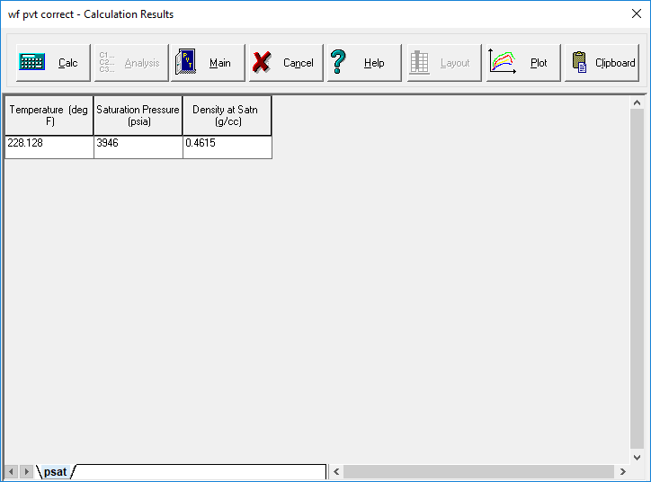

STEP 5: CALCULATE CCE AND DL
To calculate the other two experiments, we follow similar steps.
CCE: create a new stream and regress, but this time toggle CCE. Then click the CCE icon and input the temperature and pressure values. When pasting the pressure values, stop your list where the highlighted blue box stops, then move on to the next set of values until you are done pasting. Make sure it is set to User Selected, click Calculate, then Plot. If your curve matches the lab points, the model is good. If not, adjust some regression parameters, then click Main to save.
DL: under differential liberation there are three main properties we look at: oil density, oil formation volume factor (Bo) and gas-oil ratio (GOR). For this example, take each one under a new stream and regress for the property you are trying to match. Then click the DL icon, insert the temperature and pressure values, click Calculate, then Plot. Go to Variables to change the chart between Bo, GOR and density. Finally, click Main to save.
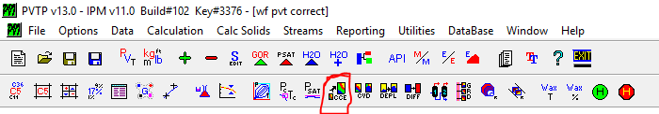
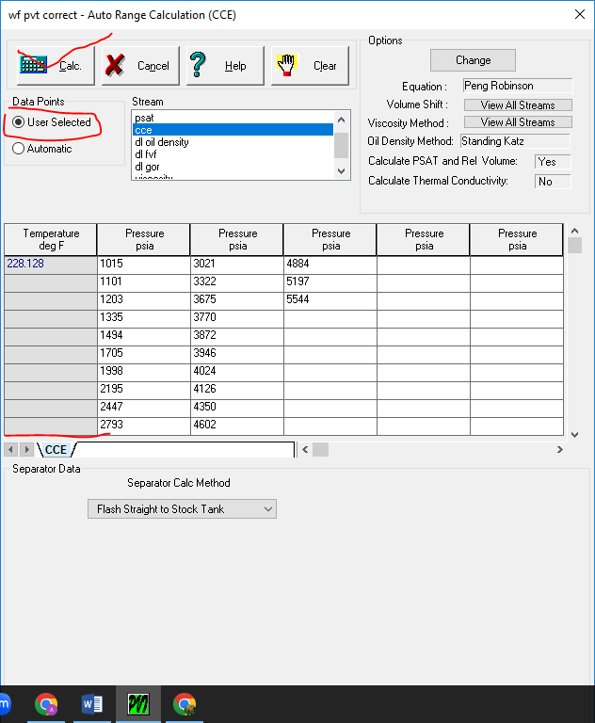
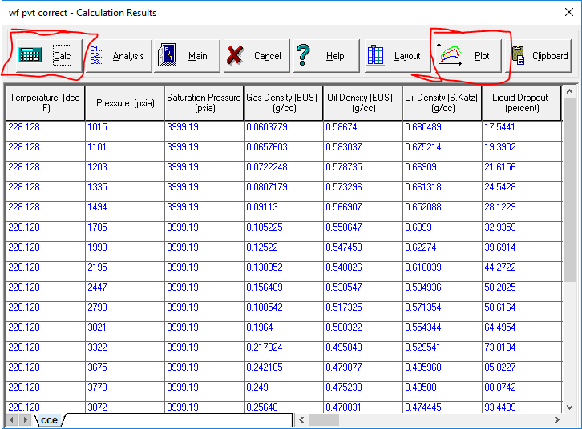
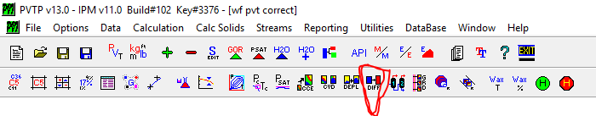
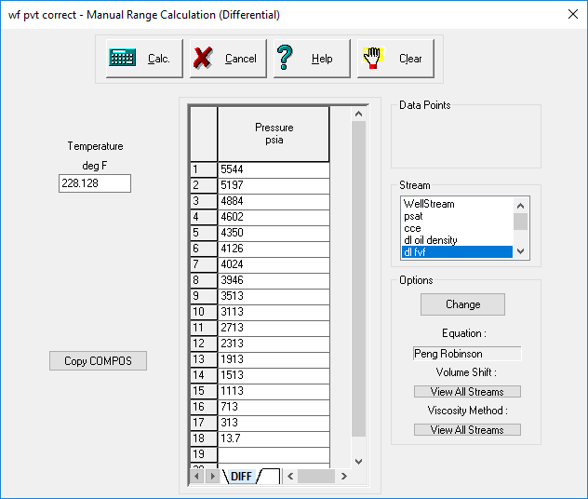
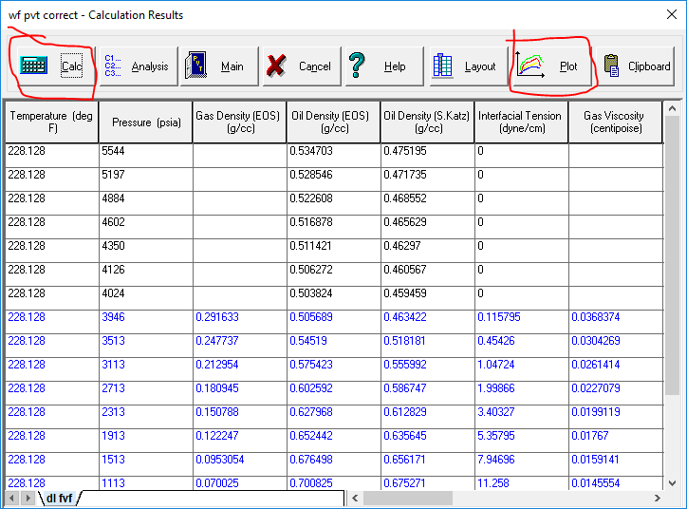

STEP 6: CALCULATE VISCOSITY
Viscosity is a bit tricky, so it is regressed and calculated separately. Regress your viscosity values first. For most of the viscosity formulas you don’t need to click All On or Clear Pure; just click Regress.
To calculate, click the DL icon, then Calculate and Plot. Go to Variables and change the variable to Oil Viscosity. This is the same way you switch between Bo, oil density and GOR: once you have plotted, just go to Variables and change the variable.
If the viscosity does not match, try a different viscosity formula, such as LBC (Lohrenz-Bray-Clark), Pedersen et al., Zhou et al. or Beggs and Beal, and see which gives the lowest error.
Once you are done with this workflow and all your graphs match, congratulations! You have now modelled the fluid. You can use it for material balance or well modelling. Hurray!!!
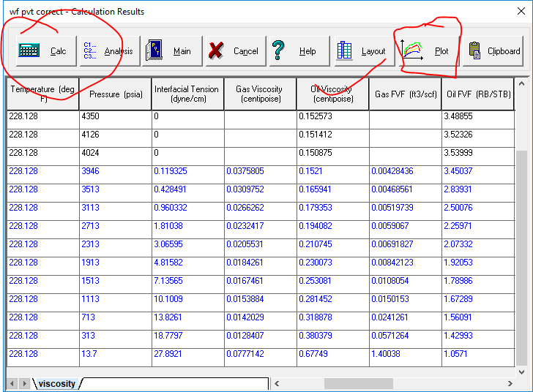
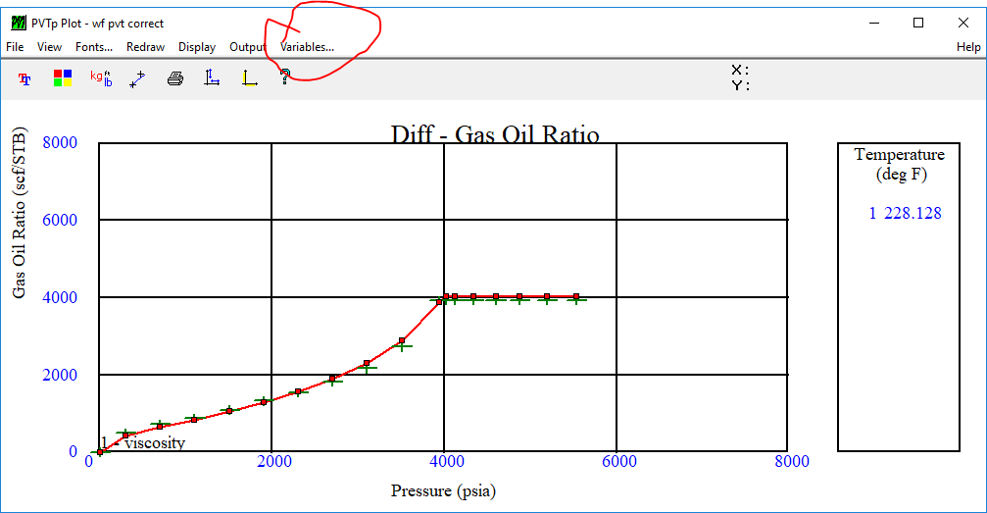
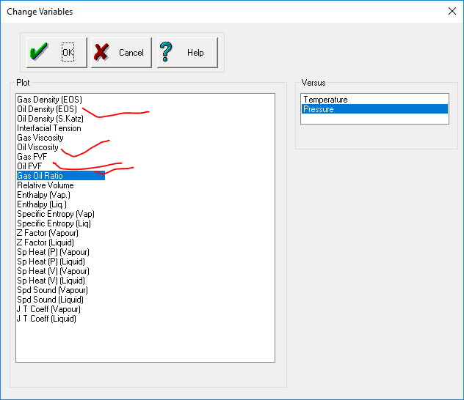

EXPECTED RESULTS
For every test you run, you should get a graph that matches the reservoir fluid properties you input. On the chart you will see a red line and some green points. The green points are the lab data and show the true pattern of the reservoir fluid. The red line is the model you are building. If the red line follows the pattern of the green points, sitting on them, your model matches the fluid.
Once you confirm a match, go to the calculated values, copy them out and compare them with your lab values. Calculate the absolute error for each point:
Absolute error (%) = |Calc − Lab| ÷ Lab × 100
Then calculate the average absolute error (AAE). If the AAE is between 0 and 5%, it is a good match.

Psat

CCE

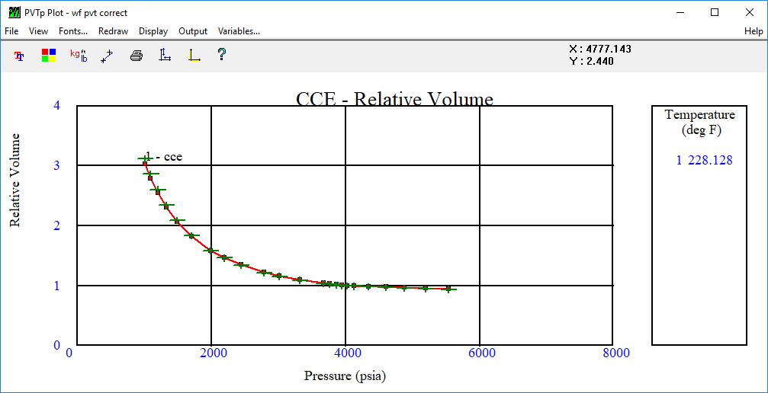
Table 1: CCE relative volume, lab vs calculated
Lab Values | Calc Values | Abs Error (%)
0.938146 | 0.949285 | 1.19
0.94872 | 0.958867 | 1.07
0.959445 | 0.968261 | 0.92
0.970172 | 0.977471 | 0.75
0.980768 | 0.986373 | 0.57
0.991014 | 0.994894 | 0.39
0.996021 | 0.998984 | 0.30
1 | 1.00644 | 0.64
1.008499 | 1.01568 | 0.71
1.021057 | 1.02917 | 0.79
1.033707 | 1.04258 | 0.86
1.090372 | 1.10105 | 0.98
1.154221 | 1.16504 | 0.94
1.215586 | 1.22553 | 0.82
1.338851 | 1.34556 | 0.50
1.461143 | 1.46366 | 0.17
1.58419 | 1.58187 | 0.15
1.832782 | 1.81955 | 0.72
2.08475 | 2.05925 | 1.22
2.336109 | 2.29746 | 1.65
2.60239 | 2.54907 | 2.05
2.857146 | 2.78928 | 2.38
3.115874 | 3.03288 | 2.66
 | AAE (%) | 0.98

Above the bubble point (while the fluid is undersaturated), the relative volume rises only slightly as pressure drops. This is because liquids are nearly incompressible. Once pressure falls below the bubble point, gas begins to come out of the oil. Gas is far more compressible than liquid, so the volume shoots up sharply. The total volume increases as pressure drops.
The AAE is about 1%. This is good and means our model represents the fluid well and can be used.

DL: Oil Density

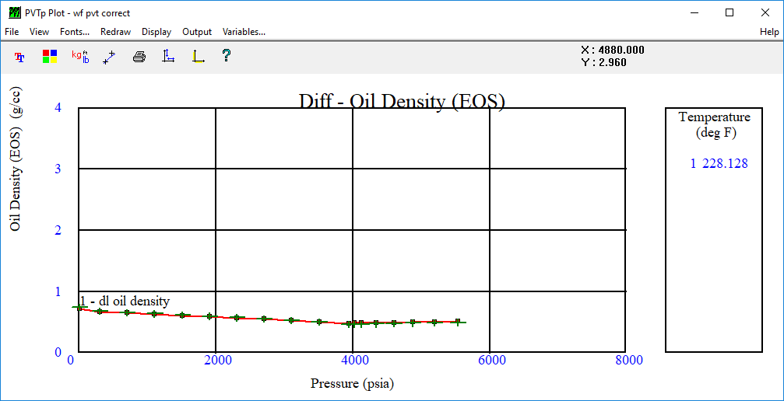
Table 2: Oil density (g/cc), lab vs calculated
Lab Values | Calc Values | Abs Error (%)
0.4919 | 0.508327 | 3.34
0.4864 | 0.502777 | 3.37
0.481 | 0.49743 | 3.42
0.4757 | 0.492277 | 3.48
0.4705 | 0.487377 | 3.59
0.4657 | 0.482758 | 3.66
0.4633 | 0.480565 | 3.73
0.4615 | 0.478848 | 3.76
0.4981 | 0.497355 | 0.15
0.5264 | 0.522844 | 0.68
0.5512 | 0.545629 | 1.01
0.5733 | 0.566795 | 1.13
0.5945 | 0.587089 | 1.25
0.6146 | 0.606892 | 1.25
0.6369 | 0.626716 | 1.60
0.6541 | 0.647345 | 1.03
0.6819 | 0.671854 | 1.47
0.7427 | 0.722446 | 2.73
 | AAE (%) | 2.26

Above the bubble point, oil density decreases slightly as pressure drops, because the oil expands. At the bubble point, the density reaches its minimum. Below the bubble point, density increases as pressure drops further. This is because the light components escape as gas, leaving behind the heavier components, so the remaining oil becomes denser.

DL: Oil Formation Volume Factor (Bo)
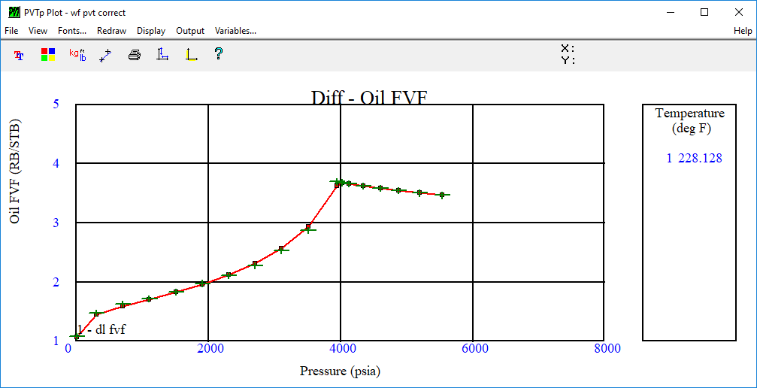
Table 3: Oil formation volume factor, lab vs calculated
Lab Values | Calc Values | Abs Error (%)
3.4632 | 3.46493 | 0.05
3.5023 | 3.50529 | 0.09
3.5419 | 3.54512 | 0.09
3.5815 | 3.58442 | 0.08
3.6206 | 3.62266 | 0.06
3.6584 | 3.65951 | 0.03
3.6769 | 3.67729 | 0.01
3.6916 | 3.61408 | 2.10
2.8739 | 2.93637 | 2.17
2.5265 | 2.57274 | 1.83
2.2764 | 2.31751 | 1.81
2.1122 | 2.12178 | 0.45
1.9743 | 1.96219 | 0.61
1.8317 | 1.8262 | 0.30
1.7196 | 1.70478 | 0.86
1.6249 | 1.58873 | 2.23
1.4757 | 1.45298 | 1.54
1.0842 | 1.06415 | 1.85
 | AAE (%) | 0.90

Above the bubble point, Bo increases slightly as pressure drops, because the oil is expanding. At the bubble point it is at its maximum. Below the bubble point it decreases, because gas is coming out of solution and the oil shrinks, leaving less total oil volume.

DL: Gas-Oil Ratio (GOR)
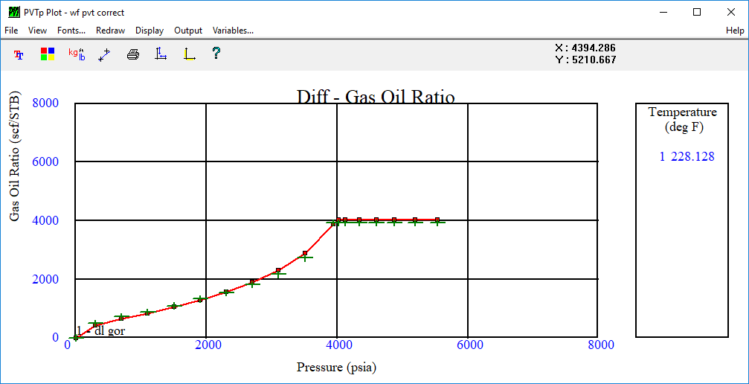Table 4: Solution GOR (scf/stb), lab vs calculated
Lab Values | Calc Values | Abs Error (%)
3918.59 | 4015.05 | 2.46
3918.59 | 4015.05 | 2.46
3918.59 | 4015.05 | 2.46
3918.59 | 4015.05 | 2.46
3918.59 | 4015.05 | 2.46
3918.59 | 4015.05 | 2.46
3918.59 | 4015.05 | 2.46
3918.59 | 3878.35 | 1.03
2718.48 | 2875.56 | 5.78
2159.22 | 2300.7 | 6.55
1816.32 | 1881.19 | 3.57
1537.08 | 1550.72 | 0.89
1319.4 | 1277.05 | 3.21
1085.44 | 1041.71 | 4.03
879.39 | 832.135 | 5.37
713.09 | 635.951 | 10.82
500.45 | 422.941 | 15.49
 | AAE (%) | 4.35

Note: the final point, where the lab GOR is 0, is left out because the error calculation divides by zero (#DIV/0!).
Above the bubble point, all the gas is still dissolved in the oil and none escapes, so the GOR stays constant. Once pressure falls below the bubble point, gas begins to escape and the curve turns downward.

Viscosity
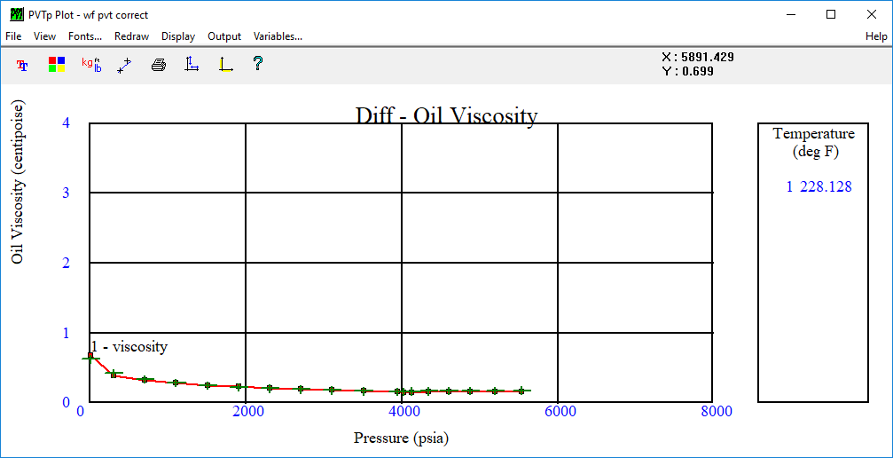
Table 5: Oil viscosity (cP), lab vs calculated
Lab Values | Calc Values | Abs Error (%)
0.17531 | 0.15843 | 9.63
0.17184 | 0.156779 | 8.76
0.16871 | 0.155256 | 7.97
0.16589 | 0.153853 | 7.26
0.16316 | 0.152573 | 6.49
0.16017 | 0.151412 | 5.47
0.1584 | 0.150875 | 4.75
0.157 | 0.1521 | 3.12
0.163 | 0.165941 | 1.80
0.178 | 0.179353 | 0.76
0.19 | 0.194082 | 2.15
0.204 | 0.210745 | 3.31
0.223 | 0.230073 | 3.17
0.25 | 0.253081 | 1.23
0.288 | 0.281452 | 2.27
0.334 | 0.318878 | 4.53
0.42 | 0.380379 | 9.43
0.624 | 0.67749 | 8.57
 | AAE (%) | 5.04

Above the bubble point, viscosity decreases slightly as pressure drops. High pressure packs the liquid molecules closely together, which increases resistance to flow. Reducing the pressure lets them move more freely. Viscosity reaches its minimum at the bubble point. Below the bubble point, it increases sharply as pressure drops further. Light molecules act as “lubricants” in the oil. As they escape into the gas phase, the remaining heavy molecules make the oil thicker and stickier.
The AAE here is slightly above 5%. This is still acceptable because viscosity is generally harder to match than volumetric properties.

HOW TO TUNE PVTP
Sometimes, when you put in your parameters, you don’t get an exact replication of the fluid you have. This means the software has gone astray in its calculations and you need to bring it back. You do this through tuning.
You tune using weights, regression formulas and by changing parameters.
Weights: in PVTP, weighting (scored 0–10) acts as a steering wheel during regression. It tells the software which lab data points are most important to match when tuning its EOS model. No mathematical model can pass through every single lab point perfectly, so weights assign an “error penalty”:
- 0 tells PVTP to ignore a bad data point entirely.
- 1 is the default baseline for standard points.
- 5–8 forces the curve closer to highly accurate lab values.
- 10 acts as a strict anchor for non-negotiable physical points, like the bubble-point pressure.
Weights work relatively, so giving everything a 10 is the same as giving everything a 1. The best strategy is to keep most points at 1 and assign high weights only to critical anchors, so the model fits real-world behaviour without distorting the overall curve.
Formulas and parameters: try a different formula or adjust different regression parameters, and see which gives a lower error for the particular property you are matching. For viscosity, the choice of viscosity correlation matters. For CCE and DL volumes, it is the EOS and regression parameters that matter.
Check your data: sometimes the issue comes from the data itself. Look carefully for points that are off, odd or don’t follow the trend, because they could be errors. If you notice any funny points, exclude them from the calculation and see if the graph improves. You can even remove them from the data completely.
So there you have it, kids. Thank you for listening. I hope this helped you a little in your PVTP endeavours. You can put any questions you have below.

